
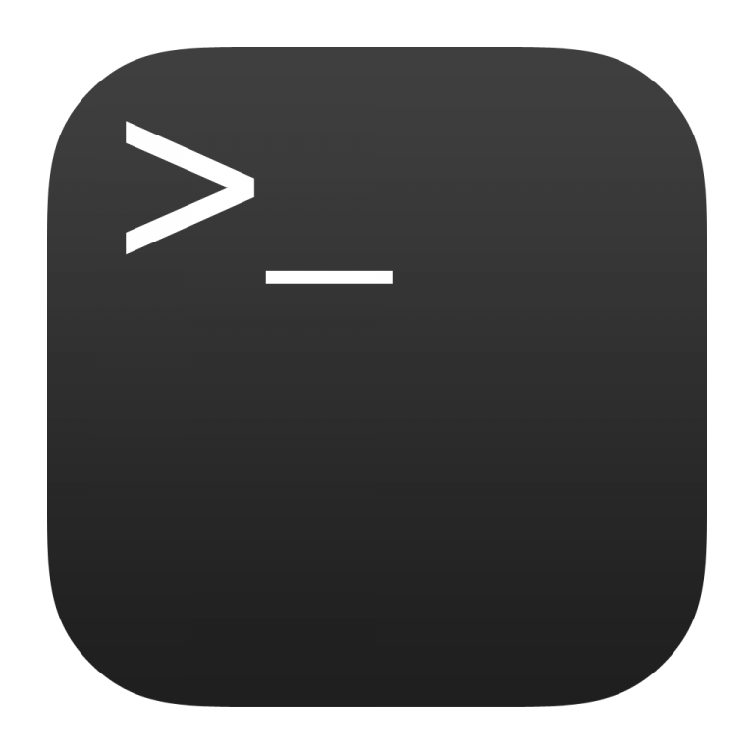

Linux: Terminal
Dan Richter - 07 Sep 2020
Alright. We have all heard about the Linux terminal, and how powerful it can be. As a new user to Linux, you may have found an icon in the Desktop Environment with a link to the terminal. Now what can you do with it?

Well, to start with, most distributions and desktop environments already have a shortcut set up to open a terminal window. Try hitting Ctrl+Alt+T as this should open the default terminal on your system. That is a handy command to remember, as once you get into using Linux, you will want to use it often.

Now, there are a lot of different commands available in the Linux terminal. They will all have the same, or very similar format.

[sudo] command [optional switch] [file or directory path]

Using ‘sudo’ will give you superuser, or administrator access. Most of the operating system will be protected from normal user access, so this will be required to access them. For right now, don’t worry too much about using it.

Linux is a case-sensitive operating system. This is important to note, as you can have the following files:
test.txt
TEST.TXT
TeSt.TxT
and they will all be separate files. This is unlike dos/Windows, which does not care about case.

When typing in commands, most of what you will be typing will be in lowercase. There are some switches that are uppercase, so be careful.

Also, watch out when using spaces. If you are going to create a directory in the terminal or GUI file manager, Linux will let you put spaces in the names. It can be difficult to access them via the terminal though.

I’m going to jump ahead here a bit, and introduce you to the ‘mkdir’ command. This is the command that can make a directory in the terminal. If you type in ‘mkdir folder name’ in the terminal, you will end up with two directories being made. ‘folder’ and ‘name’ will both be created. If you want a space in the directory name, you would have to enter ‘mkdir “folder name”’. You would then get the ‘folder name’ directory. In order to change to that directory, you would enter ‘cd “folder name”’, always within quotes.

Linux does have some great time savers in the terminal. Let’s say you wanted to change to your Documents directory from your /home folder. You could type in ‘cd Documents’, or you could type in ‘cd Doc’ and then hit the TAB key. This is the auto-complete function. It will find any matching directories, or file names, and display them on the screen. This helps when you can’t remember exactly what you named the directory, or it’s too long for you to type it. :)

Another great feature in the Linux terminal, is it will keep a history of all the commands you’ve typed in. I’m not sure off-hand how many the history file holds, but it’s quite a few. (edit, it looks like it holds the last 500 commands but this can be changed to whatever you feel you need) If you hit the Up arrow on your keyboard, Linux will show you the last command you typed in. If you keep hitting Up or Down, you can go through the entire list of commands you’ve used.

Another way of viewing your history of commands, is to type in ‘history’. This will show you a list of the last 500 commands. Very handy when you are typing in long commands.

You also have the ability to cut and paste commands to the terminal. This can be done either by right clicking on the terminal window, or using the Ctrl+Shift+C to copy and Ctrl+Shift+V to paste from the keyboard. Of course you need to highlight the text before trying to copy it.

As with dos/Windows, you can use wildcards in the terminal. Both the ‘?’ or the ‘*’ work. The ‘?’ takes the place of one character, while the ‘*’ takes the place of a string of characters.

Another great feature in the Linux terminal, is the ability to use ‘--help’ for help with just about every command. So, if you want some help with the ‘mkdir’ command, you could type in ‘mkdir --help’, and see the help file. These will usually give you a list of all of the switches that can be used with that command, along with examples of how the command is structured.

If you require more help with a command, you can always type in ‘man command’ such as ‘man mkdir’. This will bring up the manual for the ‘mkdir’ command. This manual is usually very in depth and gives you everything you need to know about a command. Very helpful if you’re unsure about which switch to use, or what parameters are needed for a command.

